Piloting into docking station

**DETECTING THE DOCKING STATION**

We used color detection algorithm to detect the white HSV color range to simplify the detection of the docking station. Each area of the resultant mask is calculated by calculating the area of the contours. The small areas that were found in the white range is neglected. Resulting the contours of the docking station. Then Applying contour approximation algorithm (*Ramer-Douglas-Peucker algotithm*) is applied to the resultant contours to detect there shapes. If left area has the shape as right area and both have 5 vertices. Then this is the docking station.

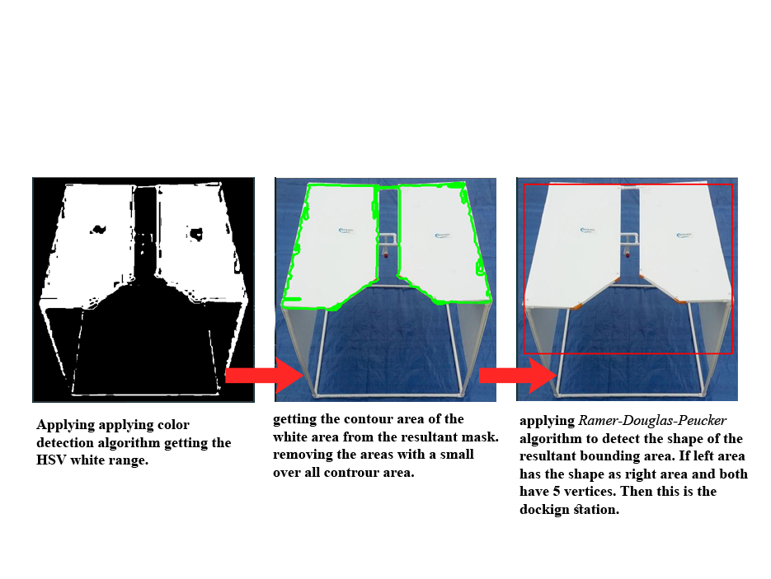

Figure 1. OpenCV Image Processing

|  |  |  |
| --- | --- | --- |
| Applying color detection algorithm getting the white color HSV range. | getting the contour area of the white area from the resultant mask. Removing the areas with a small over all contour area. | applying *Ramer-Douglas-Peucker* algorithm to detect the shape of the resultant bounding area. If left area has the shape as right area and both have 5 vertices. Then this is the docking station. |

This program uses OpenCV, an open-source computer vision library to process the received frames from the cameras connected to the raspberry pi inside the ROV.

**CONTROLLING THE ROV TO DOCKING STATION**